### **Insufficient inventory transactions with status received**

1. **Unable to process the Invoice receipt -** get the following Error

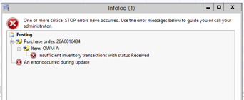

APE000123893 - Invoice: INV-00013196, Vendor: 1007029 - B & H Engine Services 2015 Ltd – P/O Number 26A0016434

APE000119727 - Invoice: INV00318772, Vendor: 1010034 - Sime Darby Transport (NZ) Ltd]- P/O Number 70A0004612

Removed marking from the inventory transaction of the PO (I took a note about the marked lot id, to be able to re-add it later)

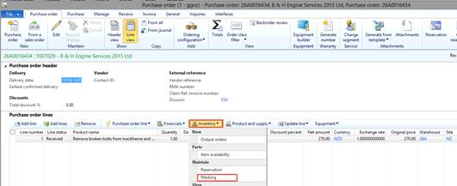

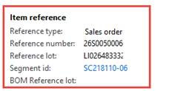

LI026483332

Select Set mark now – apply and then ok

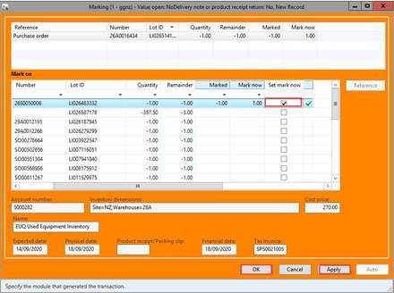

I cancelled the receipt note (I couldn't cancel it with the original date, as that period was already closed, but I cancelled it with current date

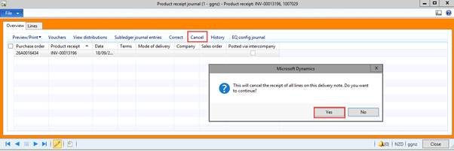

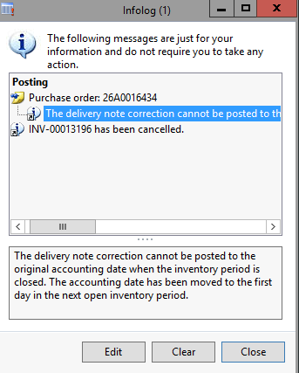

I re-posted the receipt note (with current date) (product receipt button)

I re-added marking based on the notes I took before the process.

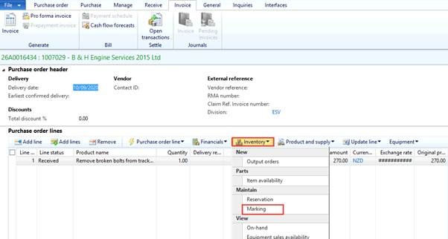

Set Mark now – apply - OK

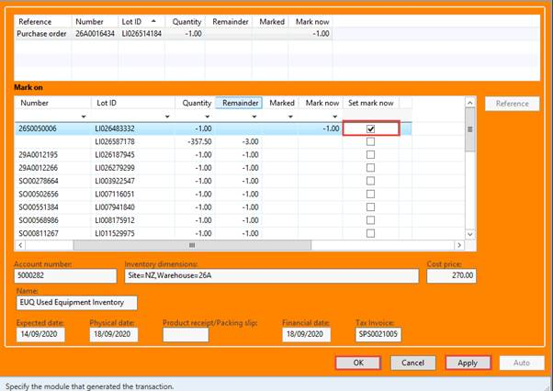

I posted the invoice for the PO without any error can also process through ExFLOW.

Get the user to post the invoice